**INTRODUCTION**

Im currently writing a program which calculates the fibonacci number of a given integer using recursion. I created my own function 'fibonacci' and made the program to run on loops as you can see in the code. The program wants me to use switch statement to operate the menu (The menu is the one where the user gets two options of either choosing to find fibonacci or to exit the program), and I am stuck on how to use switch statement in order to use the menu.

The Fibonacci numbers are the numbers in the following integer sequence. 0, 1, 1, 2, 3, 5, 8, 13, 21, 34, 55, 89, 144, …….. In mathematical terms, the sequence Fn of Fibonacci numbers is defined by the recurrence relation Fn = Fn-1 + Fn-2 with seed values F0 = 0 and F1 = 1. fibonacci-sequence

Factorial of a number n is the product of all positive numbers less than equal to n. For example, for the number $3$ the factorial of $3$ will be $3 \times 2 \times \times 1$. The factorial of a number has intensive use in permutations, combinations and probability. The factorial is represented by an exclamation mark $(!)$. Factorials also find their use in number theory, approximations, statistics. There are various functions based on factorials such as double factorial, multifactorials, hyperfactorials and so on. Gamma function is an important concept based on factorial.

**Fibonacci Series Algorithm:**

* Start.
* Declare variables i, a,b , show.
* Initialize the variables, a=0, b=1, and show =0.
* Enter the number of terms of Fibonacci series to be printed.
* Print First two terms of series.
* Use  
  1.show=a+b.  
  2.a=b.  
  3.b=show.  
  4.increase value of I each time by 1.
* print the value of show.
* End.

**Fibonacci Series Flowchart:**

[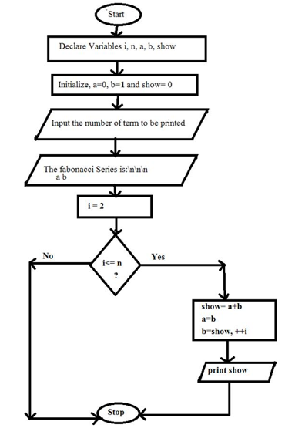](https://www.codewithc.com/wp-content/uploads/2014/07/fibonacci-series-algorithm.png)

**Factorial of no Algorithm:**

* Start.
* Read the number n.
* [Initialize]  
          i=1, fact=1.
* Repeat step 4 through 6 until i=n.
* fact=fact*i.
* i=i+1.
* Print fact.
* Stop.

**Factorial of no Flowchart:**

|  |
| --- |
| [flowchart for calculate factorial value of a number](https://2.bp.blogspot.com/-xDn2DE5BCzQ/UGyfLi6CjWI/AAAAAAAAAio/ACqBsRBWVxI/s1600/factorial.jpg) |
|  |

**CODING:-**

**INPUT:-**

#include<stdio.h>

#include<conio.h>

int fact(int n)

{

if(n==1)

return 1;

return n*fact(n-1);

}

int fibo(int n)

{

if(n == 0 || n == 1)

return n;

return fibo(n-1) + fibo(n-2);

}

void main()

{

int i,j=0,m,n,ch;

clrscr();

while(1)

{

m=0;

printf("\n1.FACTORIAL OF A NUMBER \n2. FIBONACCI SERIES\n3.exit\n");

printf("Enter your choice :");

scanf("%d",&ch);

switch(ch)

{

case 1:

printf("\nEnter n :");

scanf("%d",&n);

m=fact(n);

printf("factorial of a given number is :%d",m );

break;

case 2:

j=0;

printf("\nEnter n :");

scanf("%d",&n);

printf("fibonanci series of a given number is:");

for ( i = 0 ; i < n ; i++ )

{

printf("%d\n", fibo(j));

j++;

}

break;

case 3:

exit(0);

default:

printf("Invalid option\n");

break;

}

}

}

**OUTPUT:-**

1. FACTORIAL OF A NUMBER
2. FIBONACCI SERIES
3. EXIT

Enter Your Choice : 1

Enter n : 5

Factorial of a given number is : 120

1. FACTORIAL OF A NUMBER
2. FIBONACCI SERIES
3. EXIT

Enter Your Choice : 1

Enter n : 5

Fibonacci series of a given number is : 0

1

1

2

3

1. FACTORIAL OF A NUMBER
2. FIBONACCI SERIES
3. EXIT

Enter Your Choice : 3

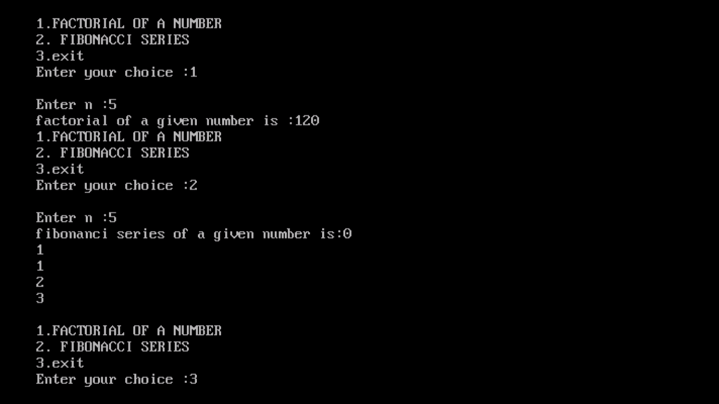

**APPLICATION:-**

**APPLICATION OF FACTORIAL NUMBER:-**

* The factorial find its use in following mathematical concepts:
* Recursion: In recursive definition of a number, a number can be expressed in an expression containing the number only.   
      [Math Processing Error]n!=n×(n−1)×(n−2)×(n−3)..(n−(n−2))×(n−(n−1))
* Permutations: Arrangement of r things out of n things when order is important.  
      [Math Processing Error]Prn = [Math Processing Error]n!(n−r)!
* Combinations: Arrangement of r things out of n things when order is not important.  
      [Math Processing Error]Crn = [Math Processing Error]n!(n−r)!r!
* Probability Distributions: There are various probability distributions like binomial distribution which include the use of factorial. To find                 probability of an event, concept of permutations and combinations is used a lot.
* Number Theory: Factorials find their use in number theory and approximations.

**APPLICATIONS OF FIBONACCI:-**

* Levels of support and resistance –

A weakness of retracements is they can only be measured by looking backward. However, these reviews offer impressive patterns. Reviewing Apple’s (AAPL) decline from a peak of $202 to a low of $79.60, we see support after 62% of the decline (red arrows) that led the price higher. Also, we see a gap through the same support (red circle) that led to the ultimate low. Applying Fibonacci levels at these events would have revealed a downside price target.

* Trend changes –

Prices often consolidate near retracement levels. Regardless of a trend’s potential, approaching retracements will slow the pace.

* Price targets –

The most applicable use of Fibonacci levels are price targets. When AAPL bottomed at $79.60 and began rallying, the 38% retracement level of $126 was an obvious price target. When the shares reached the price in a quick fashion, no one should have been surprised.

**CONCLUSION:-**

Now that you have explored the Fibonacci sequence, you should be able to see its application all around you. Fibonacci numbers, Fibonacci spiral, and the golden ratio are found everywhere. Use what you have learned to explain the Fibonacci sequence to your friends and family! I'm sure you will "WOW" them.

The conclusion here:- is that the application of the project. i.e., where all projects result can be used. The project is helpful in websites which host information related to factorial of number fibonncicy series using switch case. In a manner to give factorial of number and fibonncicy series using switch case use. Or it can be also be used as a part of the which wants to display the factorial of number and fibonncicy series using case.